
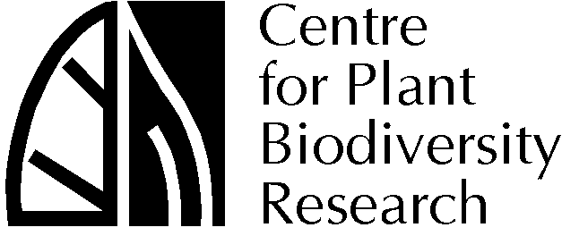

MEDIA RELEASE
6 February, 2001

Saving Rare Plants and Animals

New clues to help save rare plants and animals are revealed in a book to be launched by the the Honourable Dr Sharman Stone MP, Parliamentary Secretary to the Minister for Environment and Heritage, tomorrow at CSIRO Discovery.

Genetics, Demography and Viability of Fragmented Populations brings together research from across the world on the genetic and ecological threats limiting the survival prospects of plants and animals living in small isolated populations.

“The book provides both theory and examples of attempts to understand the genetic and ecological processes underlying extinction,” says Dr Geoff Clarke of CSIRO Entomology.

“It is only by understanding how these processes work and interact that we can hope to slow down and hopefully prevent further extinction.”

About one in four Australian native plants and animals are considered rare or endangered and many only persist in small fragmented populations as their original habitat has been so widely destroyed.

A case study taken from the book looks at the Button Wrinklewort, a small native daisy that occurs around Canberra and NSW. Now endangered owing to grassland clearing the Button Wrinklewort is often restricted to patches of less than 200 plants.

“Populations of this size have some serious problems in maintaining genetic diversity,” says Dr Andrew Young of CSIRO Plant Industry.

“Even over the short term these small populations are in grave danger of disappearing. The individual plants are so genetically similar that their ability to evolve and adapt to threats is very limited.”

It is therefore important that when considering the conservation of a species the conservation of its genetic diversity is considered.

In the case of the small Button Wrinklewort populations, if left alone, their genetic diversity and viability will deteriorate to a point the populations may disappear. If this happens in all the small populations it may lead to the extinction of the entire species.

Co-edited by Dr Young and Dr Clarke, Genetics, Demography and Viability of Fragmented Populations details genetic and ecological research into a range of plant and animal case studies from across the world.

Each case study addresses the changing genetic and demographic features of the plants and animals when restricted to fragmented habitats. And, importantly, the effect this has on their long term viability as a species.

The book will be most useful for people trying to conserve and manage species occurring in fragmented populations as it discusses possible management options.

“It is a timely reminder of how important it is for us to research and understand other species to determine the most effective way to protect them,” says Dr Young.

- ENDS -

Genetics, Demography and Viability of Fragmented Populations
will be launched by
The Honourable Dr Sharman Stone, MP
Parliamentary Secretary to the Minister for Environment and Heritage
at 8.00 am,
on Wednesday, 7 February
at CSIRO Discovery,
Clunies Ross Street,
Black Mountain, CANBERRA

ALL MEDIA WELCOME

Footage of [need some suggestions for props that the media may like to use such as specimens of plants (Button Wrinklewort) or insects mentioned in the book] will be available together with media opportunities.

More information from:

Dr Andrew Young 02 6246 5318
Dr Geoff Clarke 02 6246 4078
Sophie Clayton 02 6246 5139, 0418 626 860
sophie.clayton@pi.csiro.au

